Chemical Project Engineer

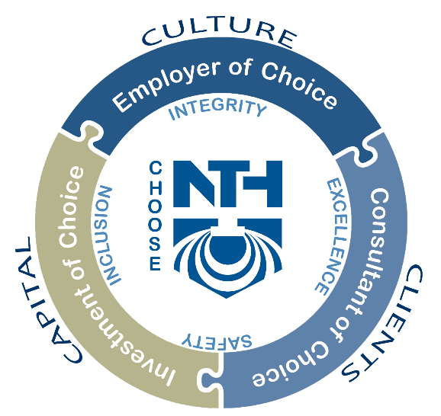
Who we are
NTH Consultants, Ltd. (NTH) has been providing professional engineering consulting services to the energy, community development, industry, transportation, and water markets since 1968. From a small, Detroit-based, geotechnical engineering firm, our company has grown into to a nationally recognized, full service infrastructure and environmental consulting firm, providing a wide range of services in civil design, geotechnical engineering, environmental engineering, and facilities engineering. Those who join our team will see first-hand the impact they have on the environment, public infrastructure, renewable energy, and community development efforts through exciting, high-profile, and challenging projects. Every day, our staff solves problems and overcomes challenges that make an immediate difference to our clients and the people they serve.

A day in the life of a Chemical Project Engineer at NTH
- Join a highly functional team in the support and development of renewable fuels and renewable energy projects.
- Provide technical expertise and management support to the Renewable Natural Gas facilitation team.
- Function as an available point of contact with clients on projects and ensure a high level of client service and satisfaction.
- Prepare and review written technical reports, safety manuals, and process information.
- Facilitate “what-if” analyses as part of hazard and operability studies (HAZOPs).
- Communicate with clients and regulatory agencies to coordinate regulatory approvals.
- Offer technical guidance and training to staff.
- Develop and present project and technical presentations to clients, technical organizations, and in-house staff.

What you need to apply
- Bachelor of Science degree in Chemical Engineering or related degree from a 4-year accredited college or university.
- 5+ years of demonstrated experience in OSHA Process Safety Management and U.S. EPA Risk Management Programs, including:
  - Coordination of initial and updates to Process Hazard Analyses (PHAs), including facilitation of hazard and operability studies (HAZOPs) using “What-if” or similar techniques
  - Development of PSM / RMP Manuals for various types of sources
  - Performance of risk management modeling and estimation
  - Ability to read and interpret process and instrumentation drawings (P&IDs)
  - Experience performing PSM / RMP audits and applicability reviews
- Previous experience in renewable natural gas, landfill gas, biogas, water treatment, chemical process or similar industries preferred.
- Previous experience with a consulting firm preferred.
- Must have strong written and oral communication skills, be able to work in a team environment as well as independently, and mentor/train staff.
- Must have demonstrated team-oriented approach to problem solving and have strong interpersonal skills for contact with clients and fellow engineers/technicians.
- Accuracy, dependability, and strong organizational skills.
- Exceptional time management skills; ability to manage multiple assignments at any given time.
- May be required to perform job duties in the field and office, during non-standard hours, as necessary.
- Must be able to lift and carry equipment weighing up to 50 lbs.
- Ability to organize technical material into comprehensive reports as well as perform QA/QC reviews on work product.
- Demonstrated leadership experience in mentoring and training junior staff.
- Demonstrated ability to seek and establish new clients and build good business relationships with both new and current clients.
- Develop and maintain professional business relationships with targeted new clients.
- Conduct periodic site / client visits, project, and business development meetings.
- Assist in developing business strategies and action plans for creating growth opportunities.
- Work with project managers to bring new clients / business opportunities to the firm.
- Must hold a valid driver’s license and be willing to travel to and conduct field work at job sites/offices in Michigan.

What you will enjoy (the perks!)
- Become an employee owner with us: company contributions to a qualified retirement plan through the Employee Stock Ownership Plan.
- We believe in work life balance: Flexible and hybrid work schedules available.
- Generous PTO package and paid holidays.
- Participation in our total rewards program with competitive salaries, and low-cost health plans.
  - Cafeteria plan options for health, dental, vision plans, and a 401K plan with a company match.
- Company paid employee assistance program for employees & families.
- Paid parental leave.
- Give back to the community through various volunteer events and fundraisers.
- Tuition reimbursement for our long-life learners.
- Professional development opportunities & paid professional memberships.

Why choose us?

In 2023, NTH was named a Crain’s Best Place to Work in Southeast Michigan, and a National & Metro Detroit’s Best and Brightest Company.

As an employee-owned firm, we take our work seriously, but we know how to have fun. We promote a relaxed company culture that focuses on improving not only our staff members' professional life, but also their personal life. We regularly schedule company activities which support employee ownership, such as golf outings, off-site company holiday party, food trucks, book clubs, ESOP month Oktoberfest celebrations, and many more team building events. We also offer a robust engagement program that focuses on all aspects of wellness. Opportunities include regular challenges, educational presentations and health initiatives, impromptu activities such as group lunch walks, healthy snack days, after work bike outings, and more.

Work Authorization
Authorized to work full-time in the U.S.A. In compliance with federal law, all persons hired are required to verify identity and eligibility to work in the United States and to complete the required employment eligibility verification document form upon hire.

AAP / EEO Statement
NTH Consultants, Ltd. is an equal opportunity employer. All qualified applicants will receive consideration for employment without regard to, among other things, race, color, religion, sex, sexual orientation, gender identity, national origin, age, status as a protected veteran, or disability.
NTH Consultants, Ltd. participates in E-Verify.

